Report

I will be talking about the evaluation of the app I created. Firstly, I started off with learning how to use XCode, with the help of tutorials to help me understand how it works. I was then able to create an app that calculate numbers, with a simple user interface, as to be able to keep the target audience engaged, and not having difficultly using and interacting with the app. At the beginning of the project, I could use Trello to layout detail of a to do list, things I’m doing and thing done. This helped in term of planning out how the app could meet the criteria and more help meet the needs and requirement of the target audience.

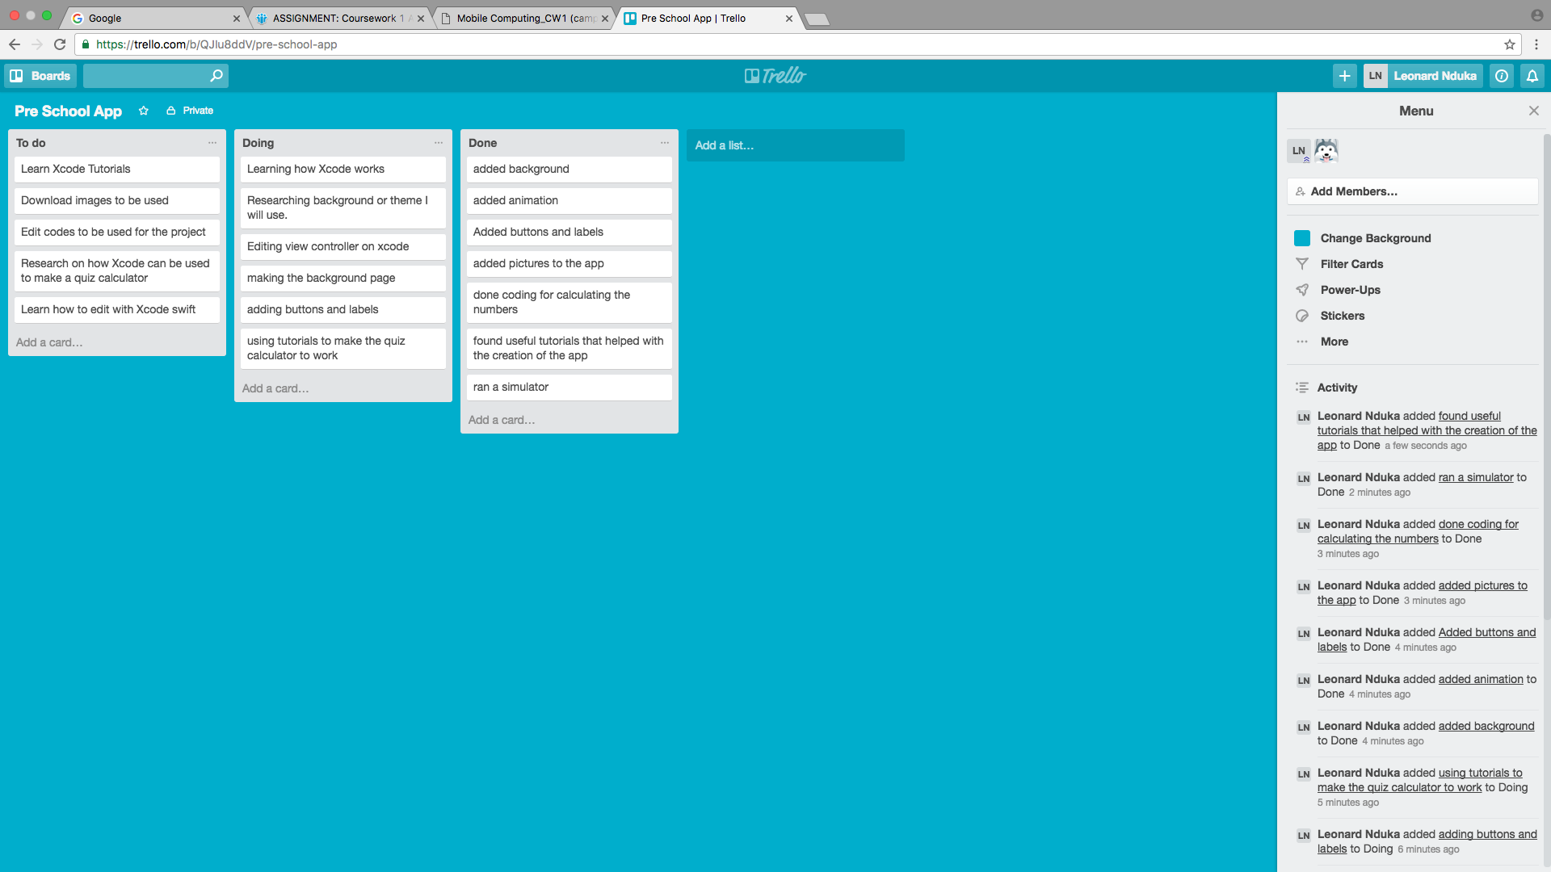

The usability of the app has been a success, in terms of the buttons implemented, animation used, ease of use, ease understanding, and more interacting feature implemented in the app. The app is aim at preschool children that are learning how to add up numbers. Mostly images were in the app because the target audience cannot read, so there they will only be able to understand images. There were lots of different interactive features to keep the target audience engaged, such as being able to use images to count so that they can get the right answer. Animation that was added to this was added to the app was the birds shaking, so that the audience could be aware that they could use it to count to get the right answer. The theme I’ve chosen for this app is the theme for the angry bird. This theme is appealing to the target audience because it will engage the target audience to using the app as it is also a very interesting theme for preschool students. The app starts off with a home play button and when its clicked on, it takes the user to the main quiz calculator where they will see question and will need to click on the correct answer, and also on this same page they will see the birds they can use to be able to count to get the correct answer. Once the correct answer is tapped on, they get a thumbs up and a smiley bird which will appear on the screen, which is to notify that they got the correct answer to the question, and if they get the answer wrong they get an angry bird that pops up for a few seconds, which notifies them that they got the answer wrong.

I used the help of Github to be able to save and show updated work I’ve done, as shown in diagram below.

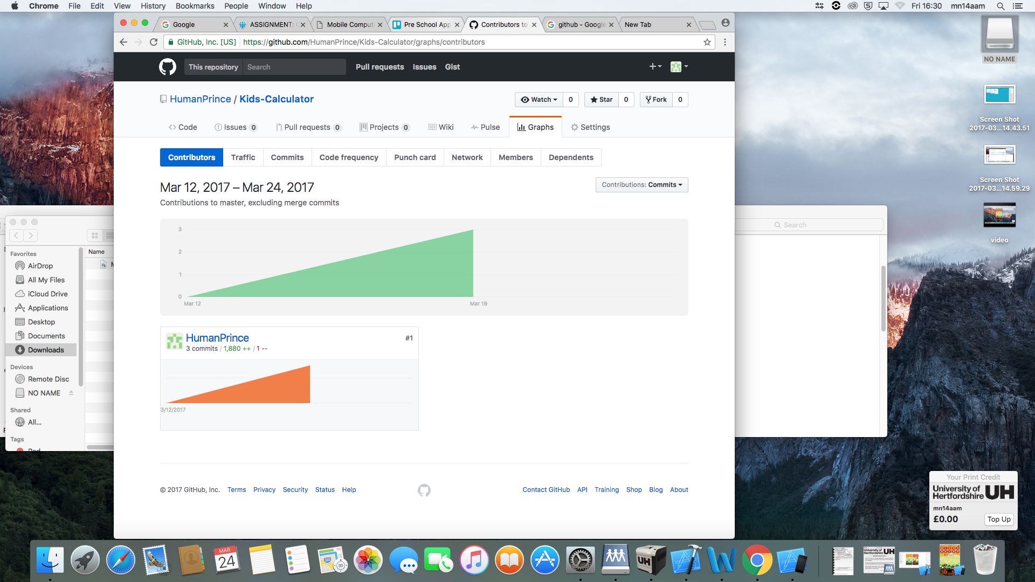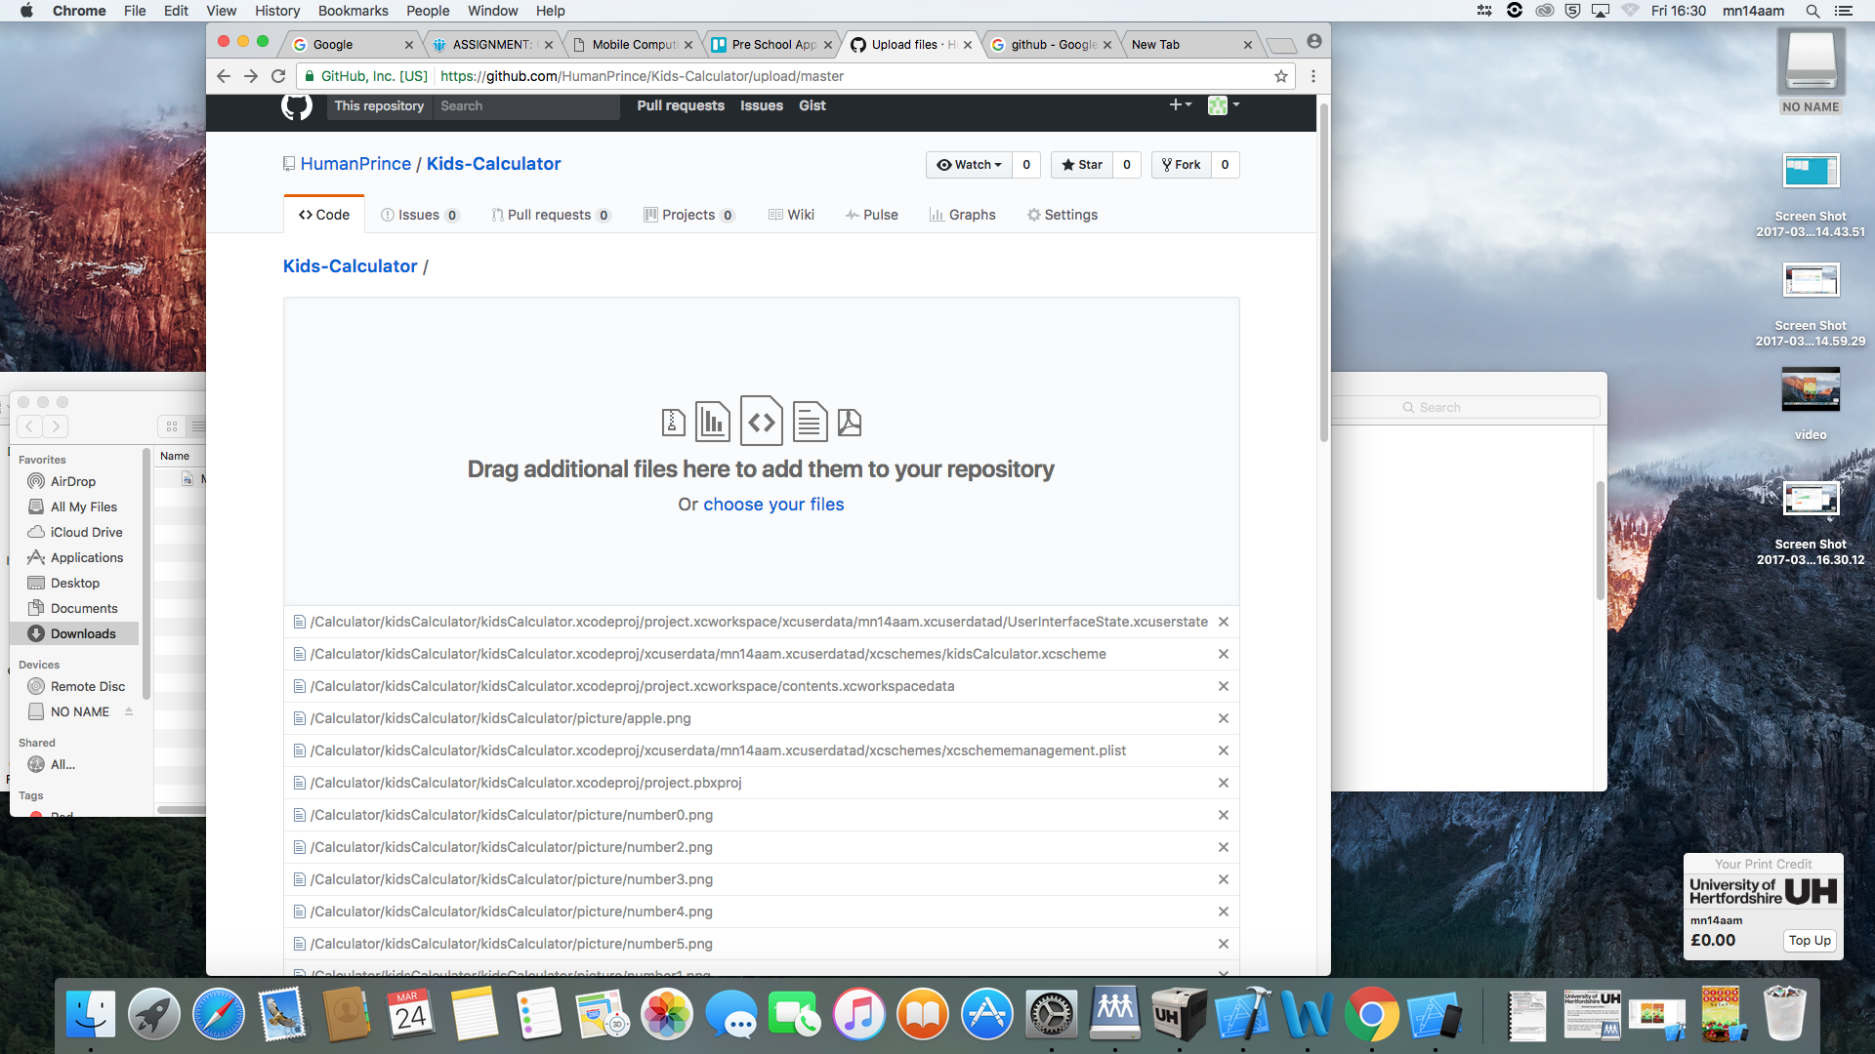

Overall I’ve been happy with the result of the project as it has taught so many things such as how to use XCode, how to be able to plan myself to be able to meet needs and requirement for the preschool app. I have also maintained consistency throughout the whole project. For further improvement on this app, I would include an audio sound, to notify the audience when they tap the correct answer and when they tap the wrong answer. I could also add more animation to keep the app more engaging for the user as this will make them even more interested to use the app, such as shaking all the number when the wrong answer is tapped on. I would also use less pictures and colours to avoid getting the target audience distracted from the main aim and purpose for the app which is mainly for educational purpose. One last improvement would also be the use of just pictures and animation to convey message to the audience, as using text means they cannot understand “correct” or “wrong” when they tap on their preferred answers.

After I created the app, I made a video to show its usability which was just over two minutes long. In the video, I showed the testing of the preschool calculator, on 3 different mobile platforms, which is the IPhone 4S, iPhone 5S and the IPhone 6s. This testing carried out show the app works properly of different mobile platform and to make sure the app fits to different iPhone screen sizes.

In Conclusion, I have talked about the usability of the preschool calculator app and have also identified what audience the app is aimed at. I also learnt new skills such as how to use and manage XCode, in which I found challenging and interesting. Other things I found challenging during the making of the app was adding animation, however with the help of tutorials I was able be learn it and implement it to the app. In general, I made the app interesting to use for the target audience as I’ve made it engaging to use, easy to understand and appealing for them to use, without getting distracted.